**Coulomb's Law**

Charles-Augustin de Coulomb, a French physicist in 1784, measured the force between two point charges and he came up with the theory that the force is inversely proportional to the square of the distance between the charges. He also found that this force is directly proportional to the product of charges (magnitudes only).

We can show it with the following explanation. Let’s say that there are two charges q1 and q2. The distance between the charges is ‘r’, and the force of attraction/repulsion between them is ‘F’. Then

F ∝ q1q2

Or, F ∝ 1/r2

F = k q1q2/ r2

where k is proportionality constant and equals to 1/4 π ε0. Here, ε0 is the epsilon naught and it signifies permittivity of a vacuum. The value of k comes 9 × 109 Nm2/ C2 when we take the S.I unit of value of ε0 is 8.854 × 10-12 C2 N-1 m-2.

According to this theory, like charges repel each other and unlike charges attract each other. This means charges of same sign will push each other with repulsive forces while charges with opposite signs will pull each other with attractive force.

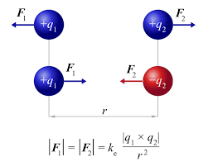

Example-1

A hydrogen atom consists of a single proton and a single electron. Calculate the electric force on the electron due to the proton.

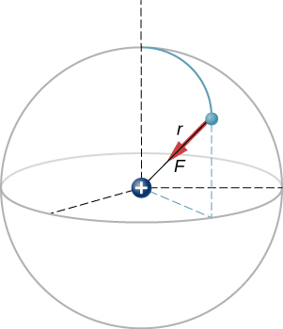

Solution: Our two charges and the distance between them are,

q1 = +1.602×10-19 C

q2 = -1.602×10-19 C

r = 5.28×10-11 m

F = k q1q2/ r2

We know that the value of k = 9 × 109 Nm2/ C2

Putting these values we get

F = 8.25×10-8 N

Example 2:

Given q1 =2e, q2 = -3e, and q3 = -5e, and that d = 2.0×10-7 m

What is the net force on the middle charge q2 ?

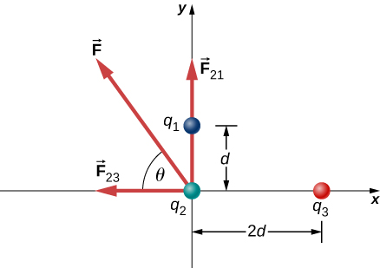

F23 = k q2q3/ r2

= (9 × 109 Nm2/ C2 )(3×1.602×10-19 C)(5×1.602×10-19 C)/(2×2.0×10-7 m)2

= 2.16 × 1014 N

F21 = k q2q1/ r2

= (9 × 109 Nm2/ C2 )(3×1.602×10-19 C)(2×1.602×10-19 C)/(2.0×10-7 m)2

= 3.46 × 10-14 N

F = 4.08 × 10-14 N

Two charges +3 micro Coulomb and +12micro Coulomb are fixed 1 m apart, with the second one to the right. Find the magnitude and direction of the net force on a −2 nC charge when placed at the following locations.

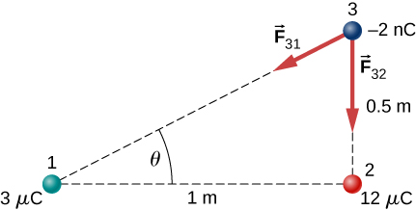

A charge q =2.0 micro coulomb is placed at the point P shown below. What is the force on q?



What is the net electric force on the charge located at the lower right-hand corner of the triangle shown here?

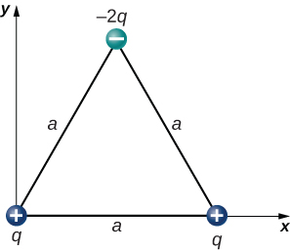

The charges q1=2.0×10-7 C q2=-4.0×10-7 C and q3=-1.0×10-7 C are placed at the corners of the triangle shown below. What is the force on q1?

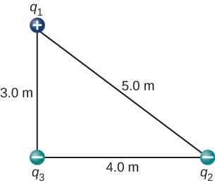

What is the force on the charge q at the lower-right-hand corner of the square shown here?

